**Team ID: PNT2022TMID16953**

**Team Leader: RAJKUMAR R**

**Team Member1: RISHIRAM K**

**Team Member2: KARAN B**

**Team Member3: SANTHOSH M**

**Mentor Name: SIVA T**

**CREATE A DATABASE IN CLOUDANT DB**

**STEPS:**

**1.LOGIN TO CLOUD.IBM.COM**

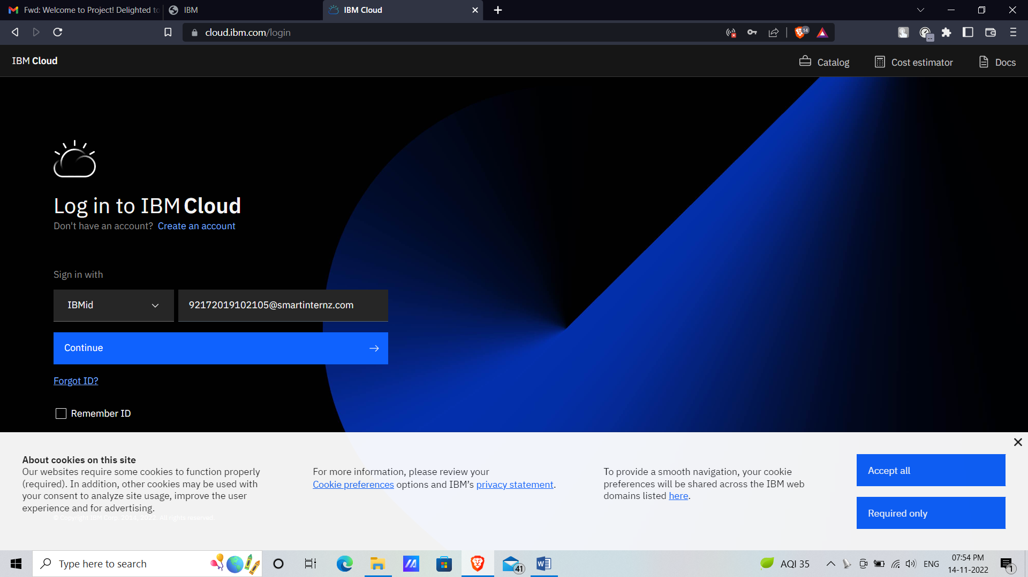

**2.CLICK ON CATLOG**

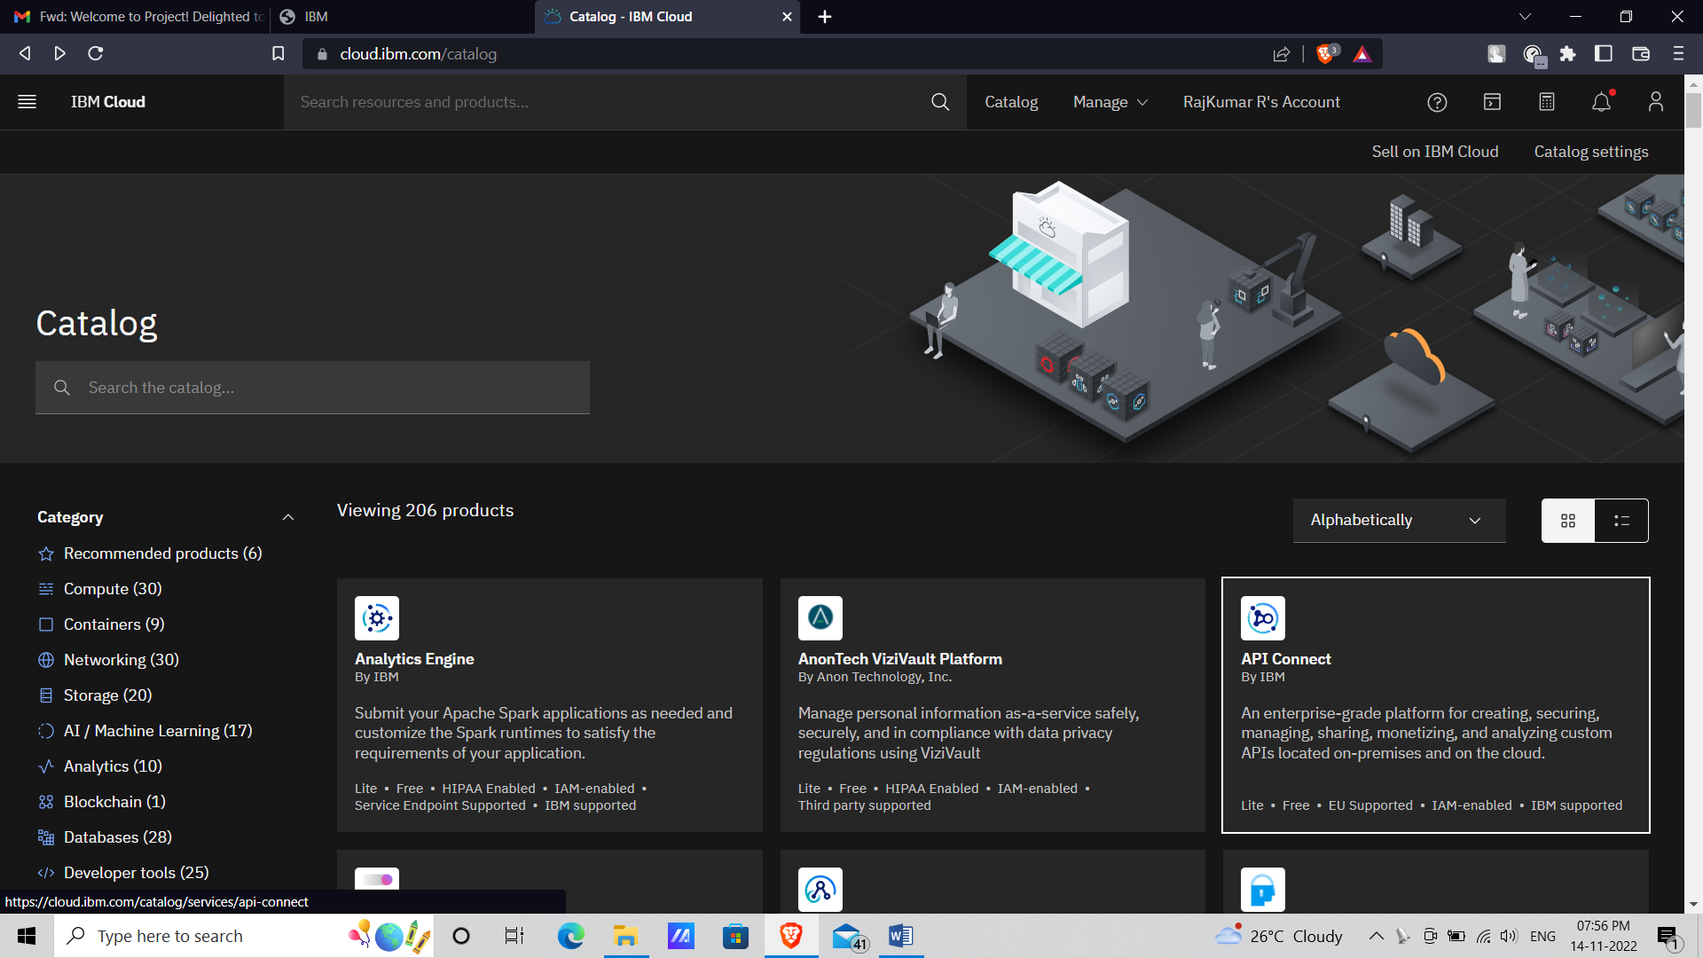

**3.SEARCH FOR CLOUDANT IN SEARCH BAR AND SELECT THE CLOUDANT**

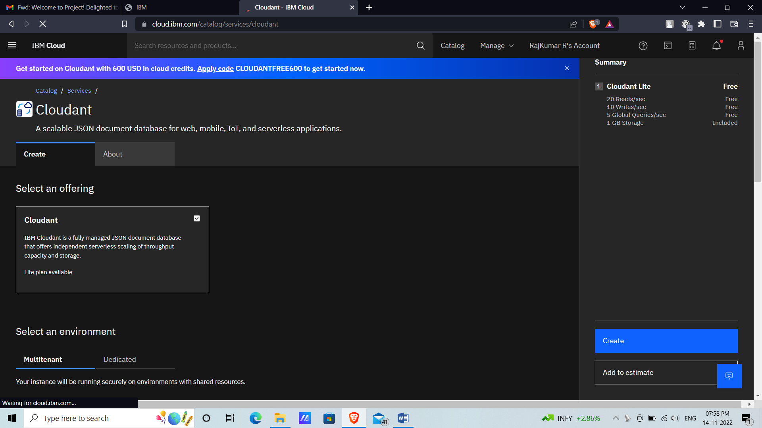

**4.ENTER THE REGION, CLUSTER NAME, REGION GROUP AND AUTHENTICATION METHOD**

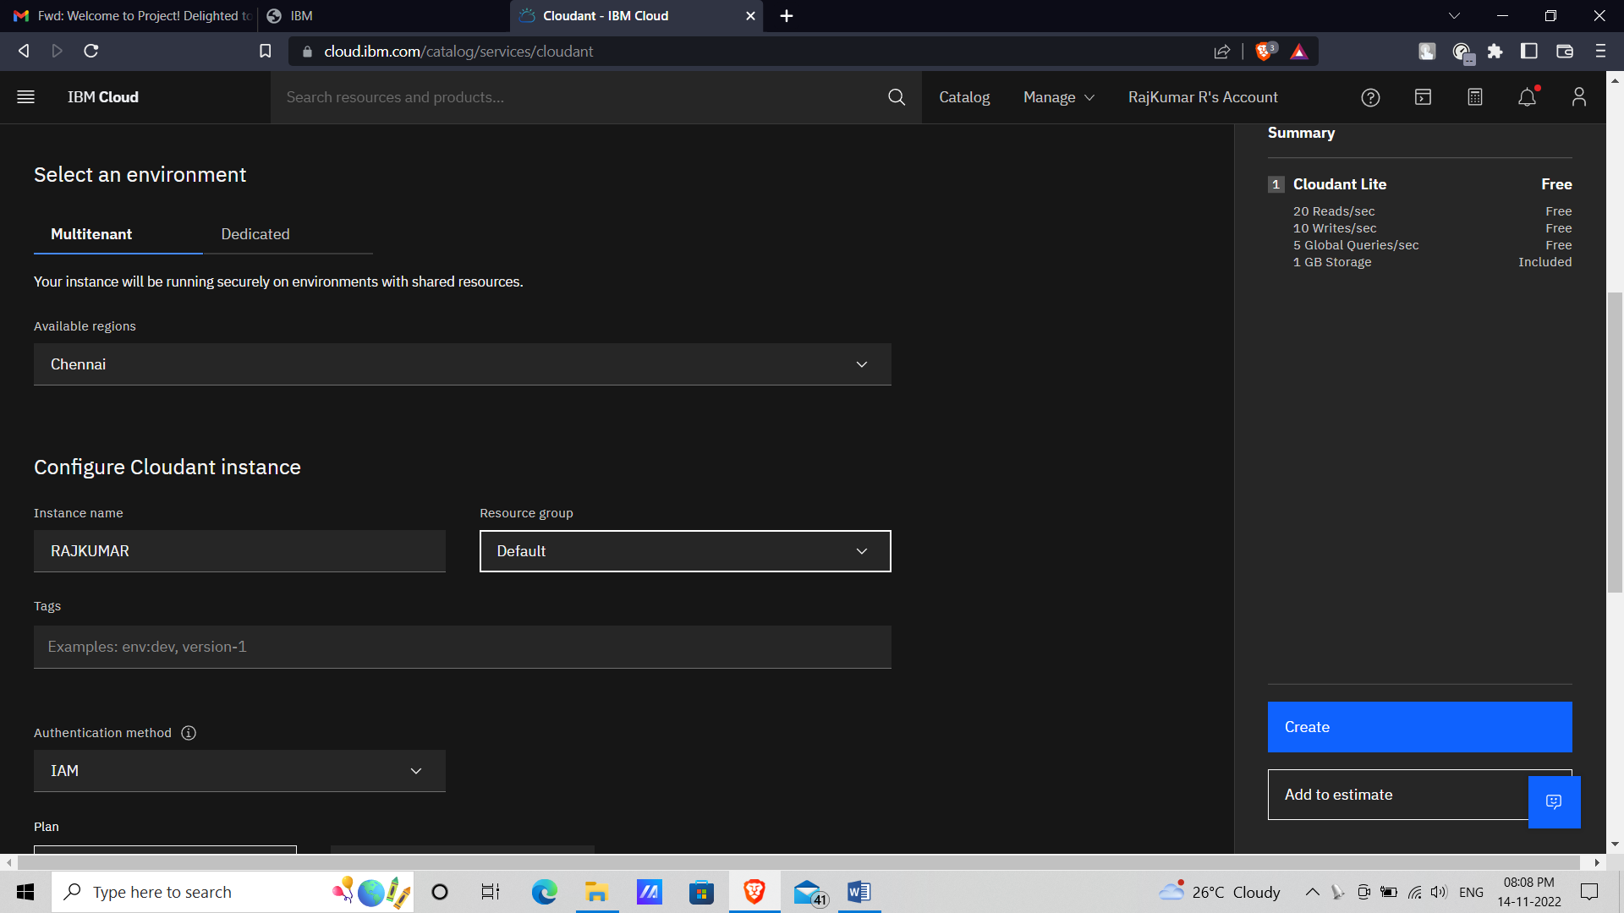

**5.CLICK ON CREATE IN THE RIGHT PANEL**

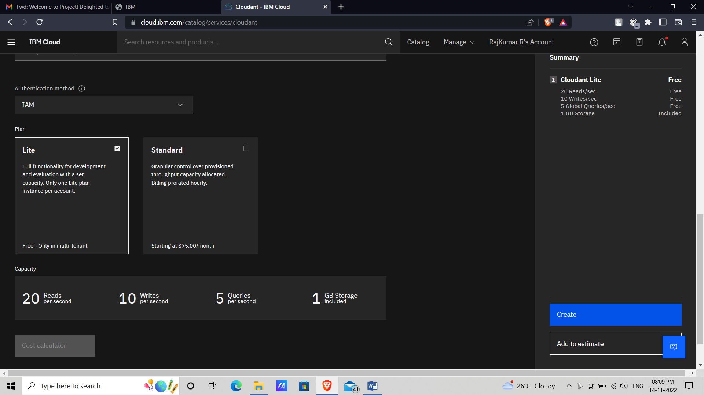

**6.IN RESOURCE LIST CLICK THE CLOUDANT CREATED**

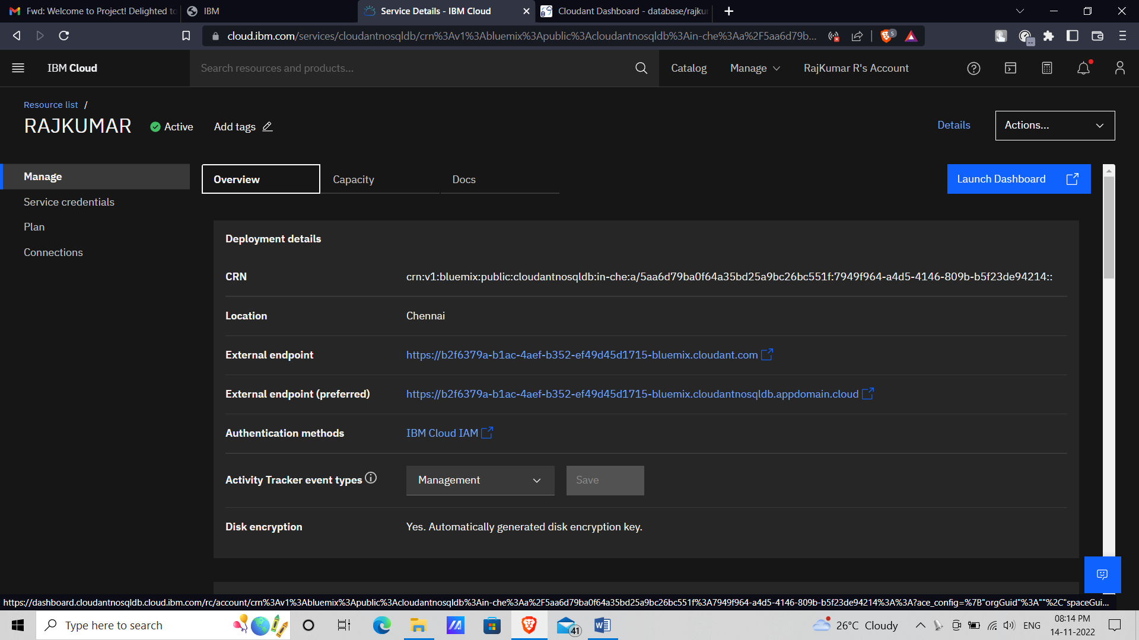

**7.CLICK ON LAUNCH DASHBOARD TO VIEW THE DATABASE CREATED**

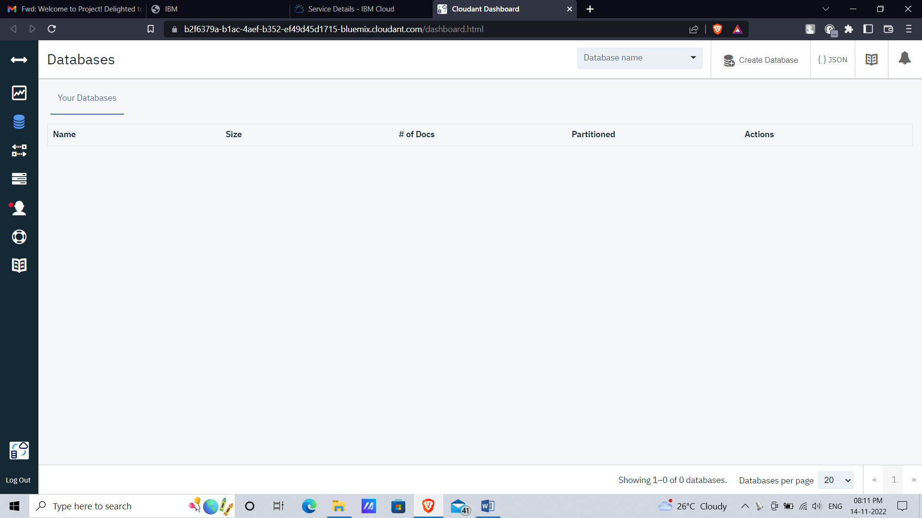

**8.IN THE EMPTY DATABASE CLICK ON CREATE DATABASE TO CREATE A NEW DATABASE**

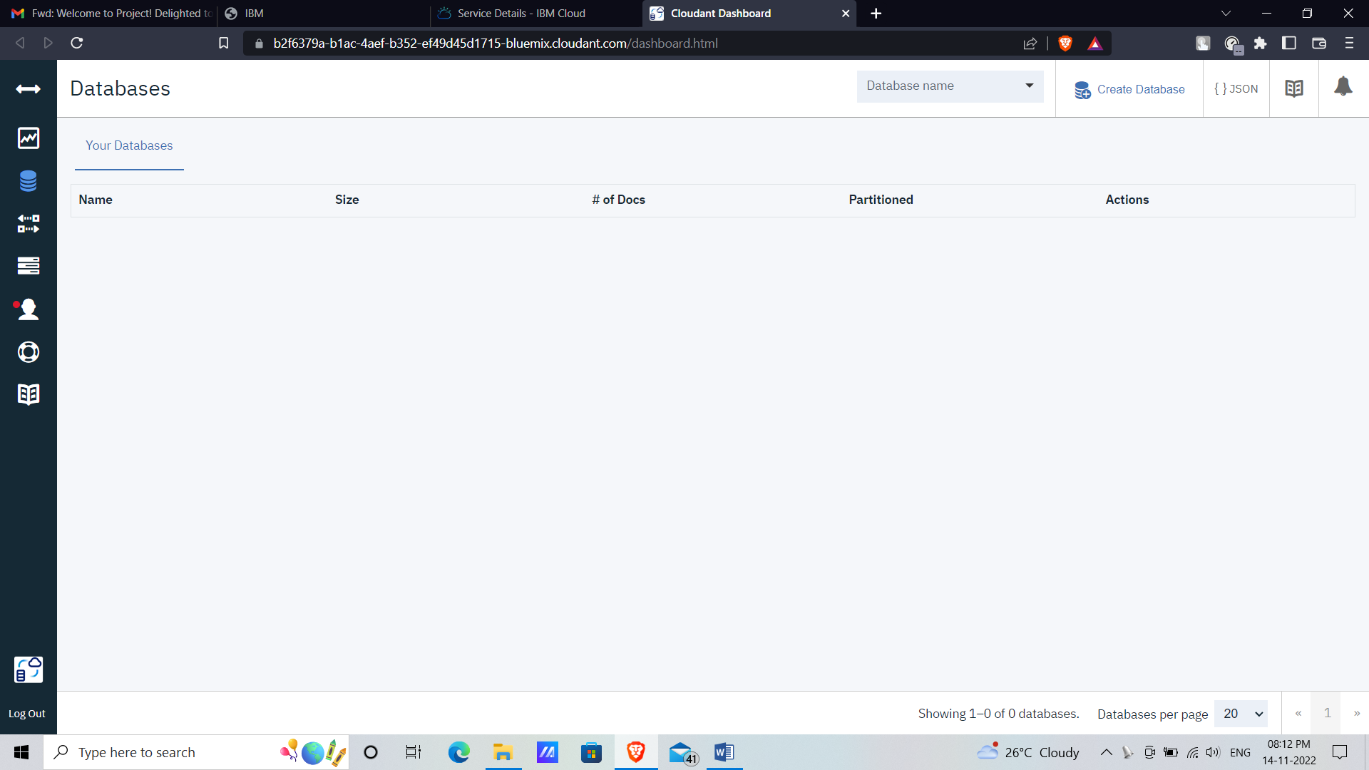

**9.ENTER THE DATABASE NAME AND SELECT PARTITIONING**

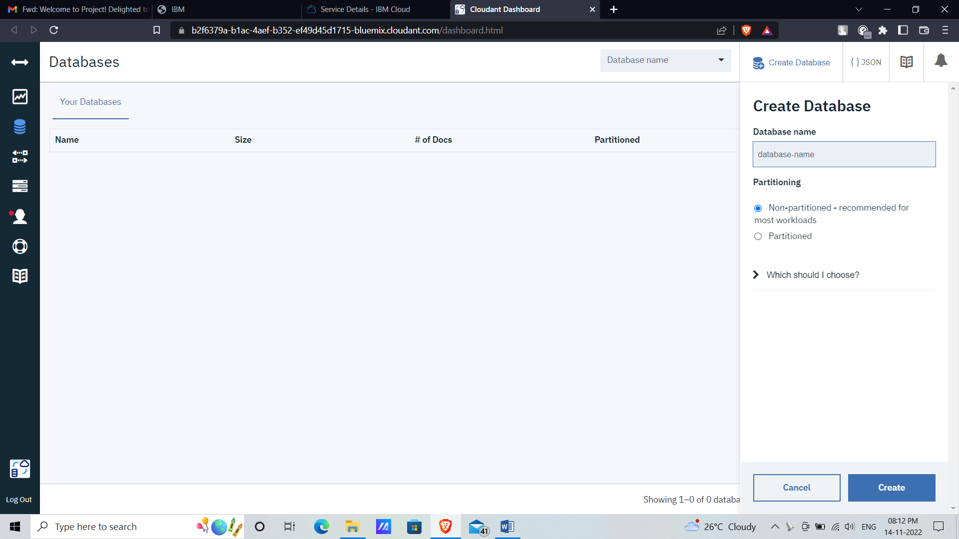

**10.THE DATABASE WAS CREATED**

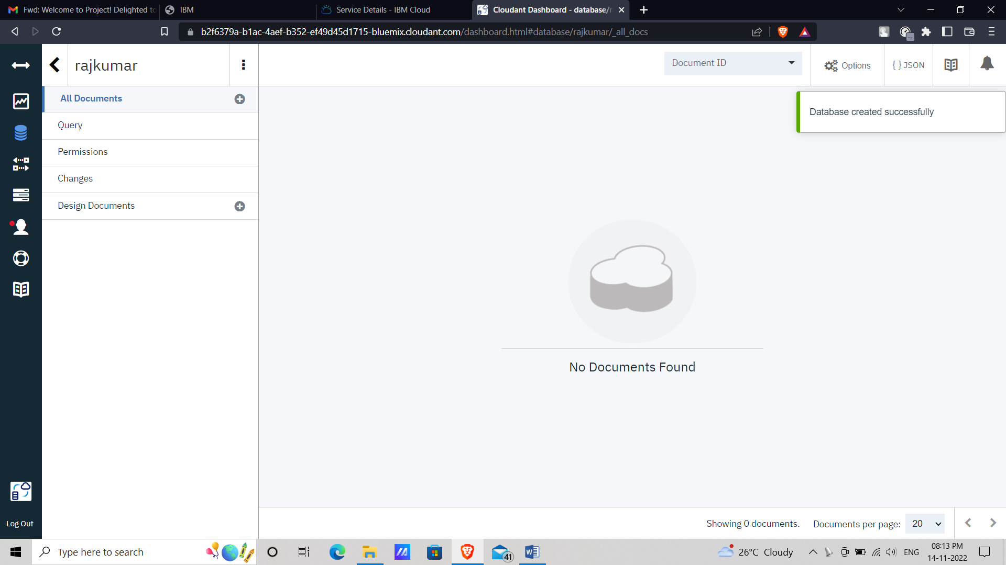

**RESULT :**

Hence the cloudant database had been created successfully.